Aim  
To create and configure a Virtual Machine with 1 CPU, 2GB RAM, and 15GB storage disk using a Type-2 Virtualization Software (Oracle VM VirtualBox).

**Procedure**

1. Install Oracle VirtualBox
   * Download Oracle VM VirtualBox from its official website and install it on the host machine (Windows/Linux).
2. Launch VirtualBox
   * Open the VirtualBox application after installation.
3. Create a New Virtual Machine
   * Click New in the toolbar.
   * Enter a suitable name (e.g., "TestVM").
   * Choose the operating system type (Windows/Linux) and version.
4. Allocate Resources
   * Assign 2 GB RAM to the VM.
   * Allocate 1 CPU core under the Processor settings.
5. Create Virtual Hard Disk
   * Select VDI (VirtualBox Disk Image) as the hard disk type.
   * Choose Dynamically allocated for space flexibility.
   * Set the virtual hard disk size to 15 GB.
6. Attach OS ISO File
   * Go to Settings → Storage.
   * Under Controller: IDE, attach the downloaded OS ISO file as a virtual optical disk.
7. Configure VM Hardware
   * Adjust video memory (e.g., 16–64 MB as needed).
   * Set network mode (e.g., NAT for internet access).
8. Install Guest OS
   * Start the VM.
   * It will boot from the attached ISO file.
   * Follow the installation wizard of the chosen operating system.
9. Remove Installation Media & Reboot
   * After installation, detach the ISO to ensure the VM boots directly from the virtual hard disk.
10. Install VirtualBox Guest Additions
    * From the VM window, choose Devices → Insert Guest Additions CD image.
    * Install the package inside the guest OS for features like better screen resolution, clipboard sharing, and drag-and-drop support.
11. Verify the VM
    * Ensure the virtual machine has 1 CPU, 2GB RAM, and 15GB disk.
    * Confirm that the OS runs smoothly inside VirtualBox.

**Output:**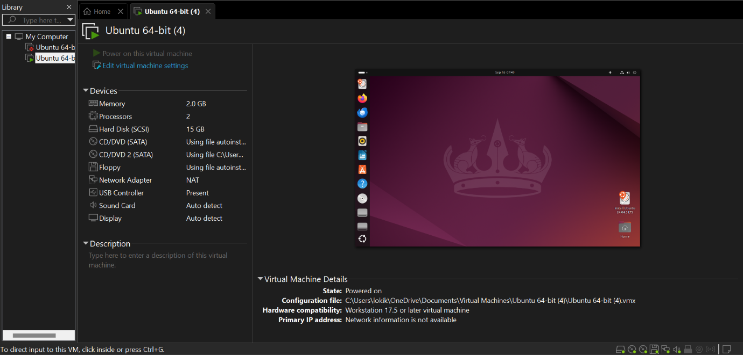

**Result**

A Virtual Machine with 1 CPU, 2 GB RAM, and 15 GB virtual disk was successfully created using Oracle VM VirtualBox (Type-2 Hypervisor). The guest operating system was installed and verified to run properly within the virtual environment